**1: Group Appliances and washing machine where item id of appliances id equal to item id of washing machine**

SELECT a.item_type, wm.item_name

FROM appliances a, washing_machines wm

WHERE a.item_id = wm.item_id

GROUP BY a.item_type, wm.item_name

ORDER BY a.item_type, wm.item_name;

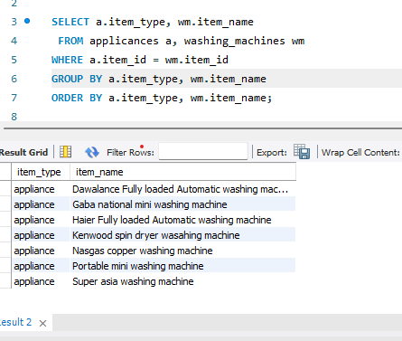

**2:** **Select items from automotives where the price is greater than the average price of items in the Tvs table:**

SELECT item_id, item_name, item_price

FROM automotives

WHERE item_price > (SELECT AVG(item_price) FROM Tvs);

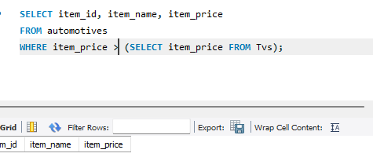

**3: Joining of medical items and medical_sales**

**SELECT WHERE ms.sale_date BETWEEN '2024-05-01' AND '2024-05-31'**

ms.sale_id,

mi.item_name,

mi.brand_name,

ms.quantity,

ms.total_price,

ms.sale_date

FROM

MedicalSales ms

INNER JOIN

MedicalItems mi ON ms.item_id = mi.item_id

WHERE

ms.sale_date BETWEEN '2024-05-01' AND '2024-05-31'

ORDER BY

ms.total_price DESC;

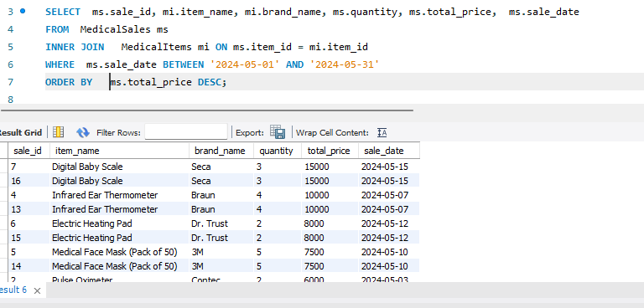

**4: Joining of Gaming and computer with Gaming sales WHERE gc.item_id IN (1, 3, 5, 7, 9)**

SELECT gc.item_id, gc.item_name, gs.quantity AS gaming_quantity, gs.total_price AS gaming_total_price

FROM gaming_and_computer gc

LEFT JOIN GamingSales gs ON gc.item_id = gs.item_id

WHERE gc.item_id IN (1, 3, 5, 7, 9);

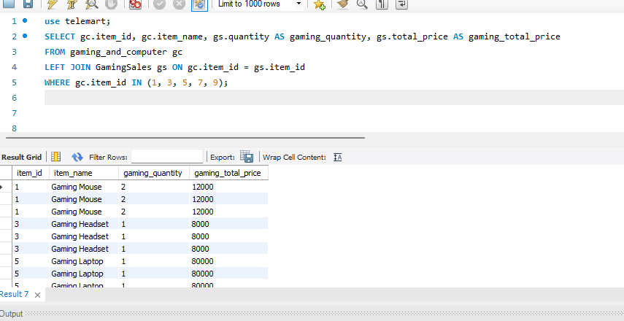

**5: Join men_fashion and FashionSales, order by total_price in descending order**

SELECT mf.item_name, fs.total_price, fs.quantity, fs.sale_date

FROM men_fashion mf

INNER JOIN FashionSales fs ON mf.item_id = fs.item_id

ORDER BY fs.total_price DESC;

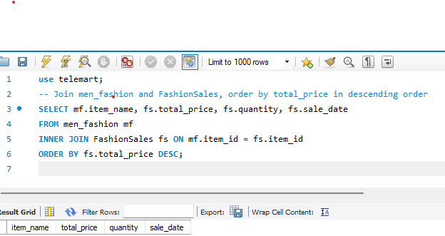

**6: Select items from men_fashion with item_id between 5 and 10 or in (15, 20, 25)**

SELECT item_id, item_name, brand_name

FROM men_fashion

WHERE item_id BETWEEN 5 AND 10 OR item_id IN (15, 20, 25);

